Name: class
Science 9 Chemistry
Unit exam REVIEW by outcome:

* Time put in before the exam, will pay off on the exam.

Outcome 1: I can investigate materials and describe them in terms of their physical and chemical properties.

You need to know:
- Physical properties and chemical properties (page 103-104)
- How materials can be classified (pure, mixture, homogeneous, heterogeneous, mechanical mixtures, solutions, metals, non-metals, etc) (page 95 – 98)
- Changes of state (Science 7 Page 220)
- Particle model (page 95)
- Physical and chemical changes (pages 99 – 102)

Answer the following questions:
- Define and give examples of Physical changes.

- Define and give examples of Chemical changes.

- Define each of the following terms and give examples. Make sure you know how to tell if a substance can be classified in that group. Draw an example molecule to prove you know it.
  - Pure Substance

  - Homogenous / solution

  - Heterogeneous / mechanical mixture

- Draw the change of state triangle (S, L, G – what it’s called as you move from one state to another). Ensure you know each change of state and the proper term.

- Write out the particle model pg. 95.

- List how to tell if a chemical change has occurred. Pg. 102

Outcome 2: I can describe and interpret patterns in chemical reactions

You need to know:
- I can identify and evaluate dangers of caustic materials and potentially explosive reactions (T1 – page 93, 442-445)
- I can observe and describe evidence of chemical change in reactions between familiar materials, by describing combustion, corrosion and other reactions involving oxygen (T2 – page 99, 103, 104 / T8 – page 158, 159)

- What does caustic mean? Give some examples of caustic materials.

- Define combustion; explain how oxygen is involved in this reaction.

- Define corrosion; explain how oxygen is involved in this reaction.

- Define and give examples of endothermic reactions.

- Define and give examples of exothermic reactions.

- List and explain the five methods of speeding up a chemical reaction.

- Explain three ways to slow down a chemical reaction

- Explain the Law of Conservation of Mass.

- Draw out the 8 WHMIS symbols and label them

Outcome 3: I can describe ideas used in interpreting the chemical nature of matter, both in the past and present, and identify example evidence that has contributed to the development of these ideas

You need to know:
- The periodic table
  - patterns in groups and families and the physical/chemical properties of the elements included (page 116-125, 129 – 131)
  - use it to determine the number of protons, neutrons and electrons for an element, draw a diagram of that element (page 128, handouts given in class about drawings)
- Explain the difference between observations and theories (page 112)
- Know the different properties of ionic and molecular compounds and give examples of each

- Use the small periodic table below. Name the family each element belongs to and state how many electrons are in their valence shell:

  - Lithium ____________________________________

  - Hydrogen__________________________________

  - Fluorine ___________________________________

  - Beryllium ___________________________________

  - Helium ____________________________________
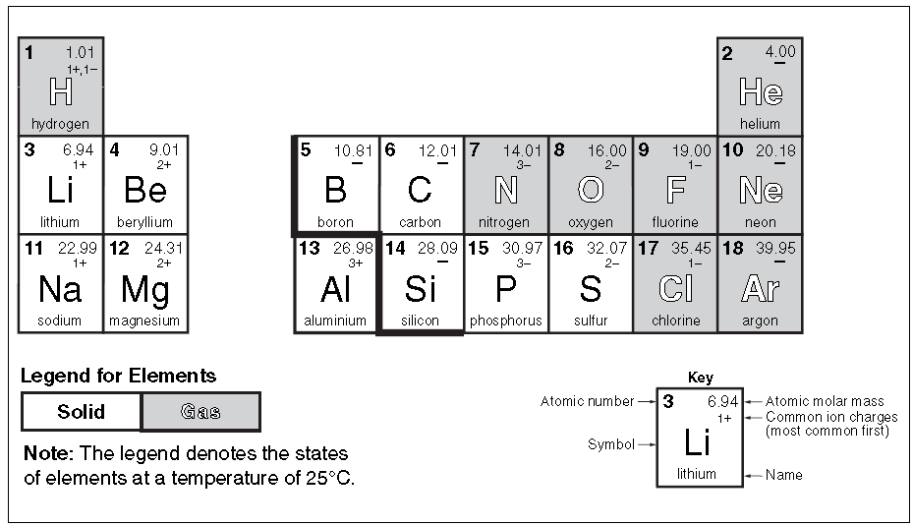

- Explain the difference between groups/families and periods in the periodic table. Label them on the periodic table on the previous page.

- Define each of the following terms and give examples.

  - Metals – they are malleable and ductile. What does that mean?

  - Metalloids

  - non-metals

- Calculate the number of neutrons chlorine has. Draw an atom of chlorine with the proper placement of electrons, neutrons, and protons (just write out how many p & n there are)
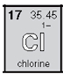

- What is an ion? Draw an ion of chlorine. Explain what the difference is between an atom and an ion of chlorine.

- Complete the following chart on Molecular and Ionic compounds.
 | Molecular | Ionic
Does it share or steal electrons?

What types of elements are combined? (metal, non-metal)

Naming rules. Prefixes, or not? What does it end in?

Forms Ions in solution? (aka can it conduct electricity)

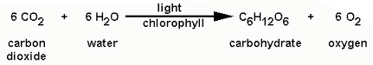
- What are reactants and what are products in the equation below? (Where are each of them found in a chemical equation?)
Formula | Compound Name | Ionic or Molecular
MgCl₂
CaO
FeS
NO₂
 | silver bromide
 | tetraphosphorus hexachloride
 | Tribromine Hexaoxide

- What are theories in science? If I said “I have a theory that the sky is blue because giants painted it that colour” – would that be a proper use of the word “theory” from a scientific standpoint? Why not?

General Outcome 4: I can apply simplified chemical nomenclature in describing elements, compounds and chemical reactions
You need to know:
- How to name molecular and ionic compounds
- How to use ion charges to name ionic compounds
- How to draw simple models of molecular and ionic compounds

- Name the following compounds, and tell whether they are ionic or molecular (aka covalent)

