**Formulas:**

**Area of Rectangle:** b x h

**Area of Triangle:** b x h ÷ 2

**Area of Circle:** 3.14 x r2

**Circumference:** 3.14 x d

Name _______________________

___ 1. This composite objects if made using 1 cm cubes. Determine its surface area

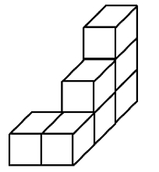

a. 29 cm2  b. 28 cm2 c. 24 cm2 d. 26 cm2

___2. How many meters (m) is 45.6 km?

a. 4560 b. 0.0456 c. 45600 d. 456000

___ 3. Find the area of the following compound shape. (use 3.14 for Pi)   
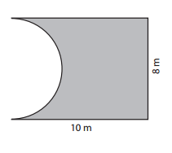

1. 54.88 m2 c. 80 m2
2. 83.65 m2 d. 60.73 m2

___ 4. The object is decomposed into a rectangular prism and triangular prism. **Calculate the area**

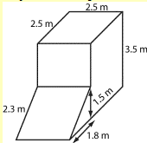

___ 5. What is the total **area of this shape?**

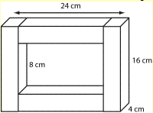

6. A **square** carpet covers 37.5% of the floor area of a rectangular room, as shown below. What is the **Side length** of the carpet shown below?

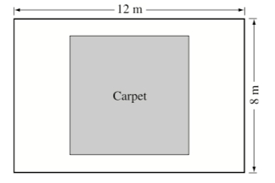

1. a. 7 m b. 6 m c. 5 m d. 4 m
2. Calculate the surface area of this rectangular prism.

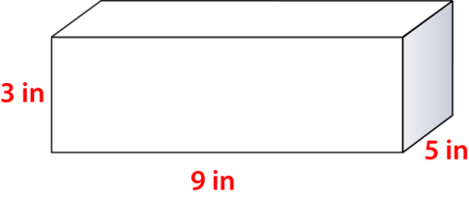

1. This figure is a CUBE on top of a rectangular prism.

Calculate the **total surface area** of the following figure



9. This object is composed of two identical cubes joined by a right rectangular prism that look like Thor’s dumbbells.

The edge length of **each cube is 8 cm.**

The **rectangular prism is 9 cm long** and has **square ends of side length 3 cm.**

Determine the **surface area** of the object.

