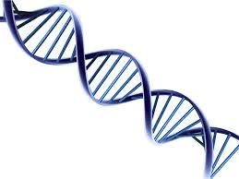
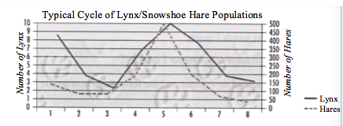
1) What type of relationship is show in the graph below?
Commensalism, mutualism, parasitism, or predator/prey?

2) Variation is extremely important. Explain why variations within a species can help that species from going extinct. Variations come in handy when there is a disease wiping them out, or if pressures in the environment are selecting for certain traits (like longer neck giraffes, or camouflaged moths)

3) What is the difference between a dominant and recessive allele? What is an allele?
Alleles are the different types of genes you get for the same trait (ex. mom and dad both give you an allele for eye colour). Dominant alleles show up in offspring masking recessive traits.

4) What is the difference between a broad niche and a narrow niche? Where would they live?
- Broad have large niches and can live in a variety of temps, food types, habitats. They can live most places because they can adapt to change.
- Narrow have small niches- controlled temp, same food, special type of habitat. They live near the equator where temperature doesn’t change throughout the year.

4a) What is another name for both of those types of species?

Broad aka generalist. Narrow aka specialist.

5) What is the difference between artificial and natural selection? (list at least 2 things)
Natural- environment selects those traits best suited to survive. Takes a very long time to see change- can lead to evolution.
Artificial- humans select for traits we want in our food, or animals that we deem useful or cute (ex. selecting the eggs from chickens that lay the most and letting them grow into more chickens). Happens quickly because humans are selecting traits.

6) The role an organism plays in its environment is called its niche- ex. producer, consumer.

7) Draw out binary fission and explain what it is: Is it sexual or asexual?

Asexual- single celled organism duplicated DNA and splits into a clone.

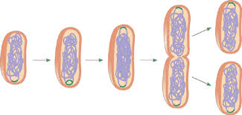

8) Inherited traits are ones that you get from your parents and pass to your children. Some can be discrete, some are continuous. Define and give an example of each:
Discrete: only a few limited options for a trait. Ex) ear lobes attached or unattached.
Continuous: a large variety of options for a trait. Ex) hair colour, height.

9) Draw out Mitosis vs. Meiosis

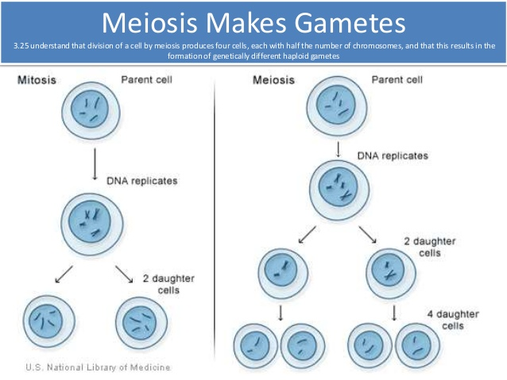

10) Explain and draw what a zygote and gamete are.

Zygote- initial 46 chromosome cell after fertilization.

Gamete- 23 chromosome sperm and egg.

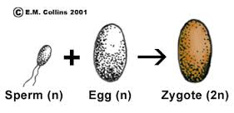

11) Label the following parts of the flower and tell which are female and which are male

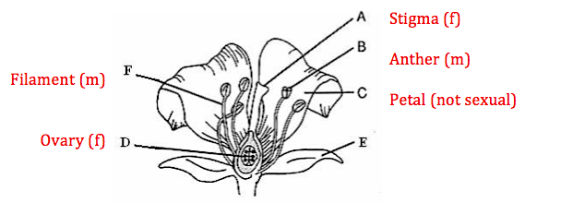

Male parts collectively called stamen
Female called pistil

12) Explain behavioural vs structural adaptations and give an example of each:
Behavioural- way an animal acts that helps it survive. Ex) migrating, puffing up to look larger.
Structural- way it is built to help it survive. Ex) teeth, claws, fur

13) Draw a simple DNA molecule and show the proper base pairings. Give the full names for A, G, T, and C bases.

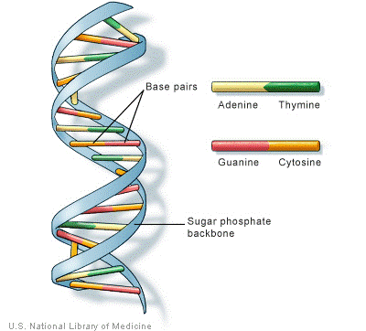

14) Describe one strategy we can take to preserve biodiversity.

Zoos- help preserve biodiversity and mate animals
Seed banks- large collection of seeds for storage
Global treaties- stop poaching
Protected areas- places like national parks protect endangered species.

