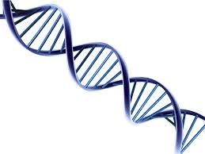
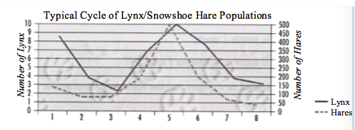
1) What type of relationship is show in the graph below?
Commensalism, mutualism, parasitism, or predator/prey?

2) Variation is extremely important. Explain why variations within a species can help that species from going extinct. _____________________________________________________

________________________________________________________________________________________________

_________________________________________________________________________________________________

3) What is the difference between a dominant and recessive allele? What is an allele?
________________________________________________________________________________________________

_________________________________________________________________________________________________

_________________________________________________________________________________________________

_________________________________________________________________________________________________

4) What is the difference between a broad niche and a narrow niche? Where would they live?
_________________________________________________________________________________________________

_________________________________________________________________________________________________

_________________________________________________________________________________________________

4a) What is another name for both of those types of species?

_________________________________________________________________________________________________

5) What is the difference between artificial and natural selection? (list at least 2 things) _______________________________________________________________________________________

________________________________________________________________________________________________

_________________________________________________________________________________________________

6) The role an organism plays in its environment is called its _____________________

7) Draw out binary fission and explain what it is: Is it sexual or asexual?

8) Inherited traits are ones that you get from your parents and pass to your children. Some can be discrete, some are continuous. Define and give an example of each: _________________________________________________________________________________________

________________________________________________________________________________________________

_________________________________________________________________________________________________

9) Draw out Mitosis vs. Meiosis

10) Explain and draw what a zygote and gamete are.

_________________________________________________________________________________________________

_________________________________________________________________________________________________

11) Label the following parts of the flower and tell which are female and which are male
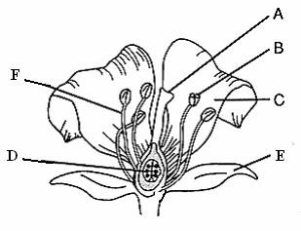

12) Explain behavioural vs structural adaptations and give an example of each:
________________________________________________________________________________________________

________________________________________________________________________________________________

_________________________________________________________________________________________________

13) Draw a simple DNA molecule and show the proper base pairings. Give the full names for A, G, T, and C bases.

14) Describe one strategy we can take to preserve biodiversity. ________________________________________________________________________________________________

________________________________________________________________________________________________

_________________________________________________________________________________________________

