1) Explain what is meant by each of the following words:
Altitude: _____________________________________________________________________________

________________________________________________________________________________________________

Azimuth: _____________________________________________________________________________

________________________________________________________________________________________________
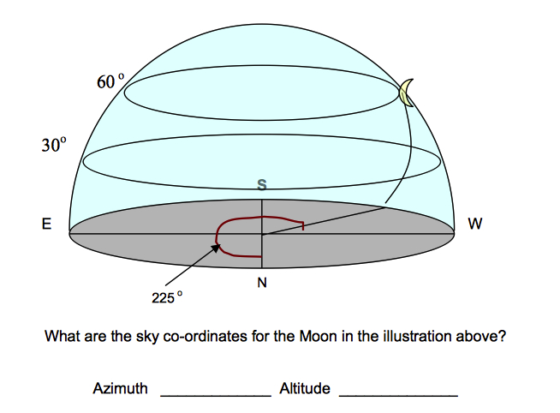

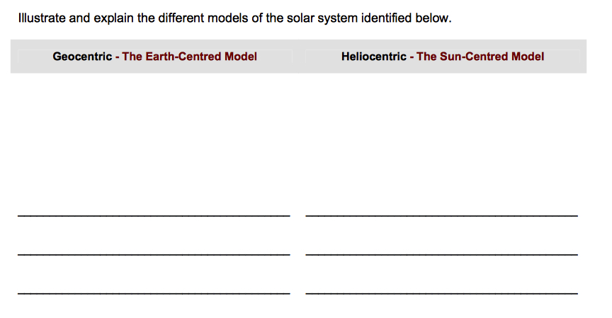
2)

2b) Which model has elliptical orbits? Which has circular orbits? ________________________________________________________________________________________________

________________________________________________________________________________________________

3) Practice reading this graph and answer questions 3 a-c.
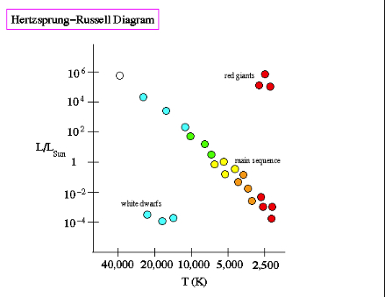

Increasing brightness

Decreasing temperature

3a) What are the two things we are comparing in respect to different stars in this graph? (hint- the axis’ of the graph) __________________________________________________

________________________________________________________________________________________________

3b) The “red giants” stars are hotter/ colder (circle one) than white dwarfs.

3c) The “White Dwarf” stars are brighter/ dimmer (circle one) than red giants.

4) What is triangulation? __________________________________________________________________

________________________________________________________________________________________________

b) Triangulation is also known as: ________________________________________________________

c) Is it best to use a small, or a larger baseline to calculate distance to stars?

_________________________________________________________________________________________________

5) The following technologies all provide information about celestial bodies in our solar system. Define each, and tell what information each one gives us.

a) light Telescope: __________________________________________________________________

________________________________________________________________________________________________

b) Interferometry: __________________________________________________________________

________________________________________________________________________________________________

c) Spectral Analysis: _______________________________________________________________

________________________________________________________________________________________________

6) A ____________________________ is the area where all new stars and planets are formed.

7) A __________________________________ is a collection of stars, planets, and other celestial objects. Ex) Ours is the Milky Way.

8) Match up each speaker’s question to what type of perspective they are showing.
“How much will it cost taxpayers to establish an outer space base?”

______________________________________
Perspectives:

- Environmental
- Political
- Ethical
- Monetary
“Who determines what resources we get on a moon base?”

_______________________________________

“Should humans test effects of zero gravity on animals?”

_______________________________________

“If we are going to use nuclear reactors on the moon base, how will we d dispose of the waste?”

_______________________________________

9) What are the three basic parts that all rockets have? _________________________________
_________________________________________________________________________________________________

10) Why does the Hubble Space Telescope produce clearer images than similar telescopes that are used on Earth? _______________________________________________

________________________________________________________________________________________________
Questions | Inner planets | Outer planets
Any natural satellites? (moons- how many?)
Density? (high or low)
Solid or gas surface?
Size? (small or large)
Far or close to sun
Temperature? (cold, warm, or hot)

Orbit time (in Earth days)

11) Complete the following table about the Terrestrial and Jovian Planets.

d) What large celestial object separates the terrestrial planets from the Jovians?

______________________________________________________________________________________

12) What is the difference between a revolution and a rotation of a planet?
________________________________________________________________________________________________

________________________________________________________________________________________________

13) On April 8, 2014, Mars was visible to the unaided eye on Earth. Is Mars producing light that we can see on Earth? What is really happening?

________________________________________________________________________________________________

________________________________________________________________________________________________

14) What is a staged rocket? Why do we use them to get to space?

________________________________________________________________________________________________

________________________________________________________________________________________________

15) When we send things into space, there are two orbits that they can follow. Geosynchronous and Low Earth Orbit. Draw what each look like and state what I would use each for.

16) Draw out what is happening during the Doppler Effect. When would we see a star as blue? When would we see it as red?

17) Read topic 8 in the textbook - how space affects the human body. Label some of the things space will do on the human below.

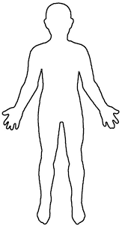

a) What do they eat? How is it different than earth food?

b) What do they drink? How is water recycled?

