NAME: _____________________

**Multiplying, Dividing, and Order of Operations With Fractions**

For each of the following: i) show all your work and steps

ii) reduce and show all final answers in mixed fractions

1. **Multiplying/Dividing Fractions:**
2.  ii)  iii) 
3.  v) 
4. **Order of Operation Questions:**
5.  ii) 

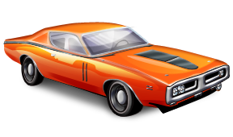**Word Problems:**

1. The stopping distance a car requires in good road conditions is given by the formula:

**d = 0.4s + 0.002s2**

where: *d* represents the stopping distance in meters

*s* represents the speed in kilometers per hour (km/h).

Calculate the distance required to stop if the person was travelling at 80km/hr. Write out the formulate, substitute in your values and solve. Box your final answer.

1. Brian has a piece of wood that is m long. He needs to cut a number of smaller pieces that are m long.
2. How many smaller pieces can he cut from the larger piece? *\*Remember, he can only have whole pieces. He may have a bit at the end that is too short or not complete.*

C:\Documents and Settings\dolezalc\Local Settings\Temporary Internet Files\Content.IE5\6STTIDRI\MCj02509440000[1].wmf

1. How much wood is left over from the larger piece

when he is finished?