Linear Relations- RETEST
Outcomes:
I can generalize a pattern using linear equations and verify.
I can graph and analyze linear equations to solve problems.

OUTCOME 1: I can generalize a pattern using linear equations and verify.

- In the equation P= 7n + 6, determine the value of P when n= 8

P = 7(8) +6
=56 + 6
=62

2) Which of the following equations would solve P= 12 when n= 3?

- P=4n + 6 b. P= 24 - 3n c. P= 4(6-n) d. P=4(n+6)

3) Determine an equation that relates the number of circles, C, to the figure number, n.
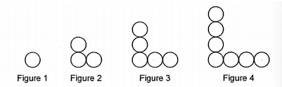
n | C
1 | 1
2 | 3
3 | 5
4 | 7
C = 2n-1

equation : _____________

4) The pattern in this table continues. Determine an equation that related the term value to the term number.
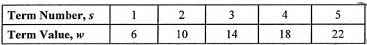

- W = 4s + 2 b. W = 6s c. w=3s + 2 d. w= 2s + 4

5) Complete the table of value.

Y = -x + 4
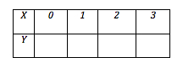

4 3 2 1

6) Mary paid $400 to join a workout team. She pays an additional $20 every time she uses the club’s facilities. Choose the equation that describes Mary’s total cost for working out.

  - C= 20n - 400 c. C= 400n + 20
  - C = 20n + 400 d. C= 20 ÷ n + 20

7) The cost to rent a pump is $30, plus $6.40 per hour. Calculate the cost of renting the equipment for 6 hours.

Cost = 6.4h + 30
= 6.4(6) + 30
= 38.4 + 30
=68.40

8. Kristina created this toothpick pattern.
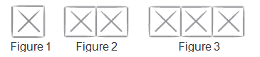
  - Make a table of values for the number of toothpicks in each figure.

Figure #  (x) | Number of Toothpicks  (y)
1 | 6
2 | 11
3 | 16
4 | 21

  - Use your table to determine the slope.
Slope = Rise/Run
= 5/1
=5
  - Write an equation in y=mx+b form to represent the relation between the figures and the toothpicks.

Toothpicks = 5n+1

  - Which figure will require 61 toothpicks?
61 = 5n+1
60 = 5n
12 = n

I can graph and analyze linear equations to solve problems.

OUTCOME 2: I can graph and analyze linear equations to solve problems.

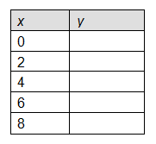
- Create a table of values for the linear relation y = 0.5x - 2.

-2
-1
0
1
2

  - Use your table of values to graph the relation.

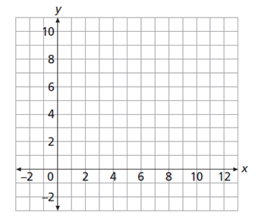

  - Use your graph, table, or equation to predict the value of y when x = 5, 7, and 12.

5, 0.5
7, 1.5
12, 4

2. Will the following graph have a positive or negative slope?
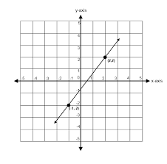
Positive
3. What is the slope in the equation y = 8x + 16 ?

8

4. What is the slope in the equation 3x + 4y = 8 ?
4y = -3x +8
y = ¾(x) + (8/2)
y = ¾(x) + 4
Slope = ¾

4. What is the slope of a line containing (-2, 4) and (4, 10).

Slope = Rise/Run
= (10-4)/ (4- -2)
= 6/6
=1

5. This graph represents a linear relation. Determine the value of y when x= -4
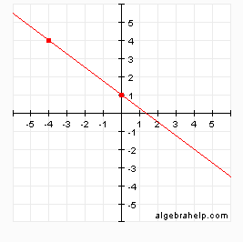

y= 4_______

6. Find the equation of the line showed on the graph. (y = mx + b)

Slope = Rise/Run
= (1-4) / (0- - 4)
= -3/4

b = Y intercept
Line intercepts y axis at (1)
Y=mx+b
Y = ¾ x + 1

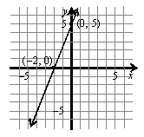

Equation ________y = 5/2 x+ 5______________________

7. Find the equation of the line showed on the graph. (y = mx + b)

Equation _______Same as question 5______________

8. Geoffrey has $130 in his savings account. Each week he withdraws $20.
  - Write an equation that relates the amount of money in his account, A dollars, after W weeks.

A = 130 – 20w

  - Create a table of values for the relation, then graph the relation. Use the w values given.

W | 0 | 1 | 2 | 3 | 4 | 5
A | 130 | 110 | 90 | 70 | 50 | 30
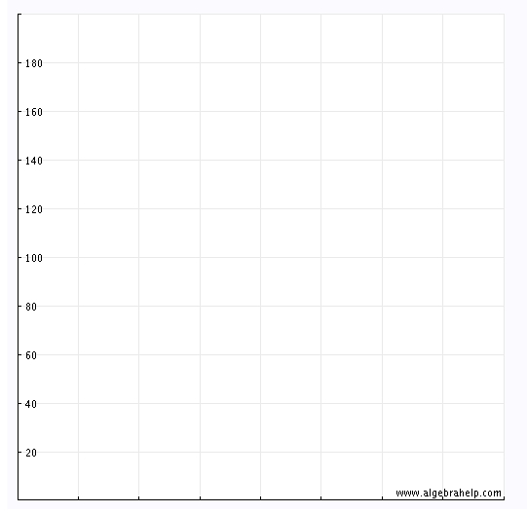

1 2 3 4 5 6 Weeks

C. At what point will Geoffrey have $50.00 in his account?

At the 4 week mark

