Extra Practice 1
Master 8.17
Lesson 8.1 Properties of Tangents to a Circle
1. Draw and label a diagram to illustrate the property of a tangent to a circle.
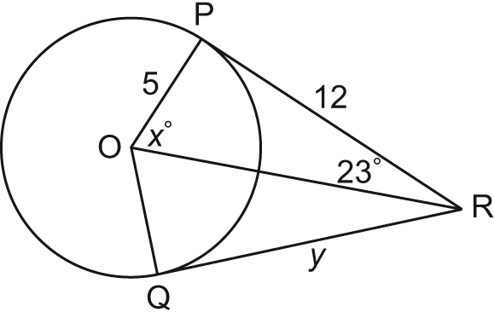

2. Point O is the centre of the circle.
Points P and Q are points of tangency.
Determine the values of x° and y.
Justify your solutions.

xº =
Y =

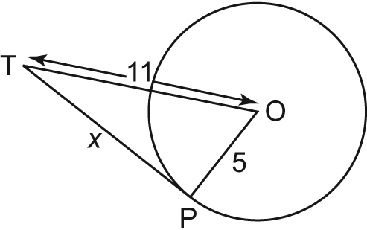
3. Point O is the centre of the circle.
Point P is a point of tangency.
Determine the value of x to the nearest tenth.
Justify your solution.
x =

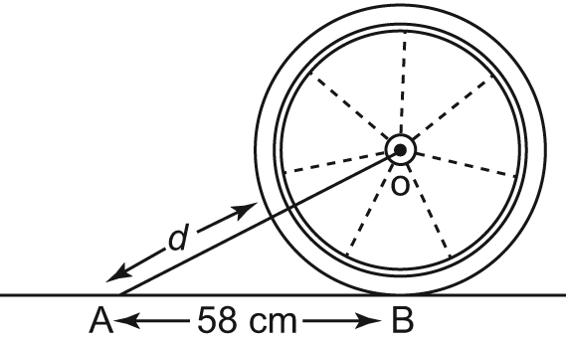
4. A wheel has radius 30 cm. It rolls along the ground toward a tack that is 58 cm from the point where the wheel currently touches the ground. What is the distance, d, between the tack and the closest point on the circumference of the wheel? Give the answer to the nearest tenth of a centimetre.

5. A circular plate has radius 13 cm.
It is packed in a square cardboard frame whose 4 edges just touch the plate.
What is the distance, d, from the centre of the plate to a corner of the frame?
Give the answer to the nearest tenth of a centimetre.

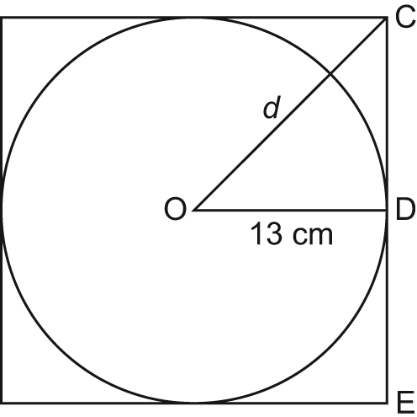

Extra Practice 2 Lesson 8.2 Properties of Chords in a Circle
Master 8.18
1. Draw and label a diagram to illustrate the relationship between
a chord, its perpendicular bisector, and the centre of a circle.

2. Point O is the centre of
the circle. Determine the
xº =
yº =
values of x° and y°.

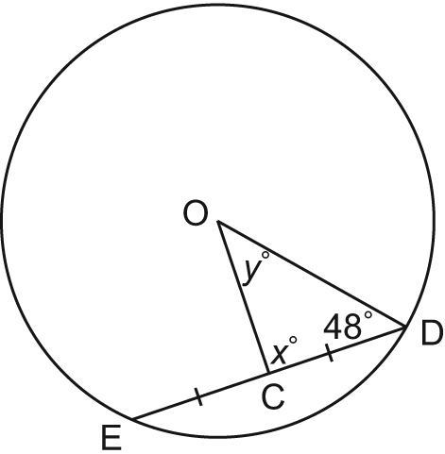

3. Point O is the centre of the circle; OF = 18 cm; and GJ = 14 cm.
Determine the values of x and y to the nearest tenth of a centimetre where necessary.
y =
x =

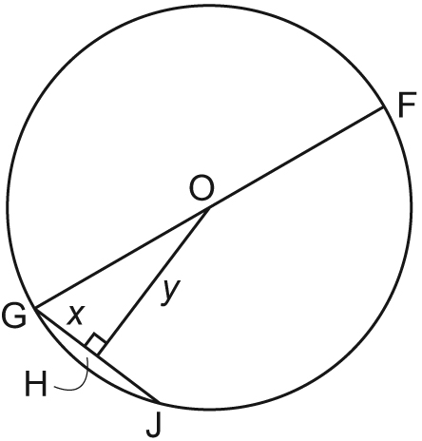

How far is the chord from the centre of the circle? Give the answer to the nearest tenth of a centimetre.

4. A circle has diameter 70 cm.
A chord in the circle is 50 cm long.
Label the circle.

5. A circle has diameter 22 cm.
Two chords are drawn on opposite sides of the centre of the circle.
One chord (a) is 16 cm long and the other chord (b) is 12 cm long.

- Which chord is closer to the centre of the circle?
Show your proof.

Chord B

Chord A

b) How much closer to the centre is this chord?
Give the answer to the nearest tenth of a centimetre.
Extra Practice 3
Master 8.19
Lesson 8.3 Properties of Angles in a Circle
1. Draw and label a diagram to illustrate each property.
a) an inscribed angle and a central angle subtended by the same arc

b) inscribed angles subtended by the same arc

c) an angle inscribed in a semicircle

2. Point O is the centre of each circle.
Determine the values of x° and y°.
Justify your solutions.

a) b) c)
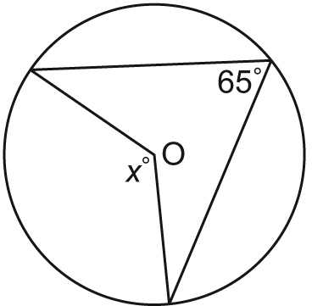 | 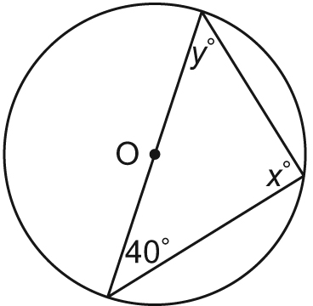 | 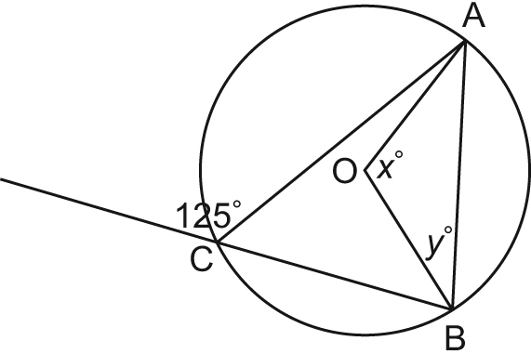
3. Use the properties of inscribed and central angles to explain why
all angles inscribed in a semicircle are right angles.

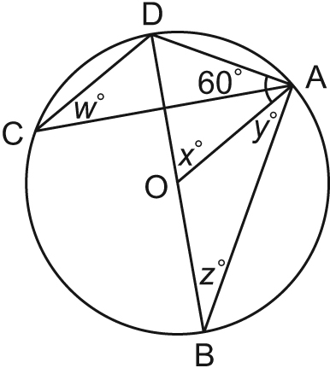
4. A student looked at the diagram below and concluded that x° = y°.
The student justified that conclusion by saying that both angles are subtended by arc AB.
What is the student’s error?
What are the values of x° and y°?
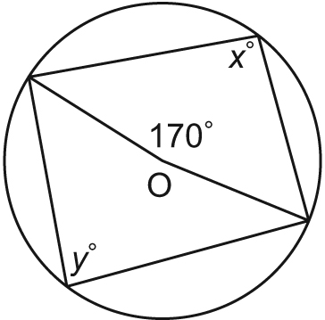

5. Point O is the centre of the circle; DB is a diameter.
Determine the values of w°, x°, y°, and z°.
Justify your solutions.

Extra Practice and Activating Prior Knowledge Sample Answers
Master 8.20

Extra Practice 1 – Master 8.17
Lesson 8.1
1. Point O is the centre of the circle.
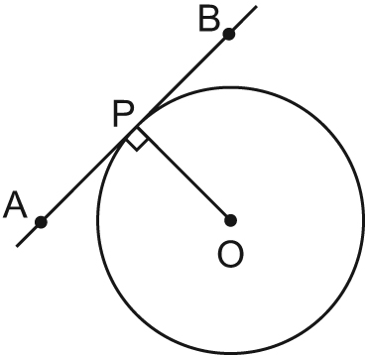
2. x° = 67°; y = 12
3. x 9.8
4. The distance between the tack and the closest point on the circumference is about 35.3 cm.
5. The distance from the centre of the plate to the corner of the frame is about 18.4 cm.
Extra Practice 2 – Master 8.18
Lesson 8.2
1. Point O is the centre of the circle.
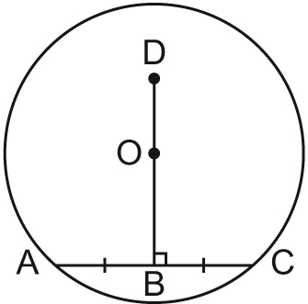
2. x° = 90°; y° = 42°
3. x = 7 cm; y is about 16.6 cm.
4. The chord is about 24.5 cm from the centre.
5. a) The closer chord is the 16-cm chord.
b) The longer chord is about 1.7 cm closer.
Extra Practice 3 – Master 8.19
Lesson 8.3
1. a) b)

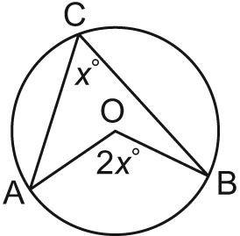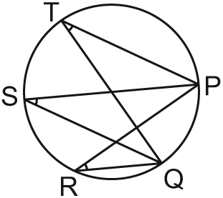

c)
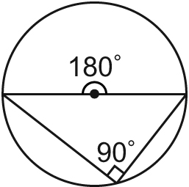

2. a) x° = 130°
b) x° = 90°; y° = 50°
c) x° = 110°; y° = 35°
3. The measure of the central angle subtended by a semicircle is 180°. From the inscribed and central angles property, the inscribed angle subtended by the same arc is one-half the measure of the central angle. So, the inscribed angle subtended by a semicircle is one-half of 180° = 90°.
4. The student’s error is in treating minor arc AB and major arc AB as the same arc.
y° = 85°; x° = 95°
5. x° = 60°; w° = z° = y° = 30°
Activating Prior Knowledge – Master 8.21
1. a) c = 15 b) b = 12
c) c 17.4 d) a 19.1

Activating Prior Knowledge
Master 8.21
Check
Applying the Pythagorean Theorem Quick Review

In any right triangle, the sum of the squares of the two shorter sides
is equal to the square of the longer side.
^{a2 + b2 = c2}
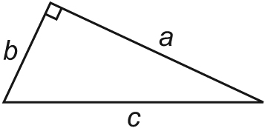

If you know the lengths of two sides of a right triangle,
you can use this formula to calculate the length of the third side.
Example
For each triangle below, determine the unknown length.
Give the answers to the nearest tenth.
a) b)
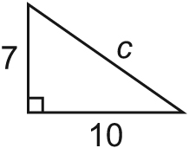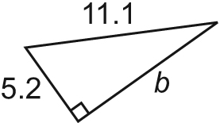
Solution  a) a² + b² = c²  7² + 10² = c²  49 + 100 = c²  c = 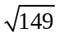  c 12.2 | b) a² + b² = c²  5.2² + b² = 11.1²  b² = 123.21 – 27.04  b = 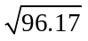  b 9.8

1. For each triangle, determine the length of the unknown side to the nearest tenth when necessary.
a) b) c) d)


