- Nutrients definition:

- Organic nutrients (definition):

- Organic molecule | Role in nutrition | Dietary source

- Minerals: two types-

Plants convert solar energy into food energy for us by photosynthesis. They take in water and minerals by root hairs.

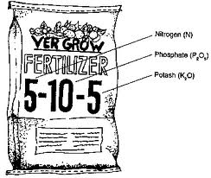
5) Nitrogen helps grow:

Phosphorous helps grow:

Potassium helps grow:

- 3 types of Pesticides and what they control:

- List some in about the insecticide DDT

PRO

CON

- Definition of biological magnification (aka biological accumulation).

- ACID (acidity) | BASE (alkalinity)
Things about acids: | Things about bases:

- During an acid- base neutralization what 2 products are created.

10)What is a Catalytic converter?

11)What are scrubbers?

12) what does ppm stand for, and what does it mean?

13) Acute toxicity | Chronic toxicity
Definition: | Def:
Ex) | Ex)

14) what does LD50 mean?

15) What is more toxic? Botulinum (LD50 in ppm = 0.0000003) or nicotine (LD50 0.86ppm)

Non persistent pollutants | Persistent pollutants
Def: | Def:
Ex) | Ex)

16) Biological indicators definition:

17) Substrate definition:

18) Point source | Non-point source
Definition

Ex) | Ex)

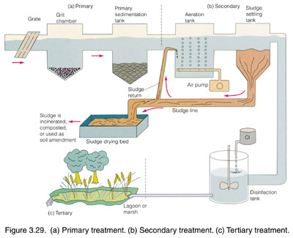

Primary –

Secondary-

Tertiary-

Biodegradable –

Leachate-

Practice Questions for Environmental Chemistry
- Match the term with the appropriate description

Number | Term
1. | Enzyme
2. | Lipid
3. | Carbohydrate
4. | Mineral

Found in grains and rice _____
Found in canola oil and margarine _____
May be classified as a trace element _____
Not classified as a nutrient, acts as a catalyst _____

- Match the term with the appropriate description

Number | Term
1. | Trace element
2. | Macro mineral
3. | Protein
4. | Lipid

Used for building and cell repair _____
Nutrient found in oils _____
Calcium _____
Iodine _____

- Match the term with the appropriate description

Number | Term
1. | Biomagnification
2. | Persistence
3. | Pesticide resistance
4. | DDT

The build up of a chemical in animals at different levels of the food web _____
Process that allows a species to adapt to the presence of a pesticide _____
Characteristic of DDT that makes it harmful to the environment _____
Can severely affect the reproduction of birds of prey _____

- Match the term with the appropriate description

Number | Term
1. | SO₂ (sulfur dioxide)
2. | pH scale
3. | Acid
4. | Base

A chemical with a pH of >7 _____
A chemical that turns blue litmus paper red _____
Compares the relative acidity or alkalinity of a substance _____
Produced by the combustion of fossils fuels and contributes to acid rain _____

- Order the following substances from most acidic to least acidic

Number | Substance | pH
1. | Baking soda | 8.2
2. | Drain cleaner | 14
3. | Lemon juice | 2.0
4. | Acidic rainfall | 4.4

_____, _____, _____, _____,
most acidic least acidic

6. You are a biologist hired by Environment Canada to study the amounts of DDT in a wetland environment. Your field work provides the following data:
Sample | DDT concentration (ppb)
Water | 0.0001
Plankton | 0.2
Fish | 40
Osprey | 5200

- How many times greater is the concentration of DDT in the osprey than in the plankton? Show your work. [2 marks] cg+

- What process is being represented by the data? [1 mark] cg

- Explain how the DDT from the plankton can accumulate in the osprey. [2 marks] eg
7. Place each of the following substances (use their number) on the pH scale provided. [5 marks] cg-

Number | Substance | pH
1 | Battery acid | 0.5
2 | Drain cleaner | 14
3 | Human blood | 7.4
4 | Natural rainfall | 5.6
5 | Milk | 6.6

0 7 14

8. List a function and an example food for each of the organic compounds below:

a. Carbohydrates

b. Lipids

c. Proteins

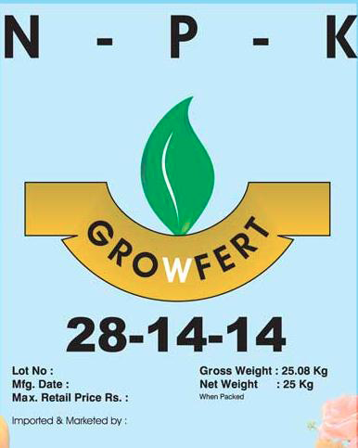

9. Use the image to the right, explain what the numbers
and letters on the bag of fertilizer means (what do they help grow?).

N

P

K

10. State whether each sentence below refers to an acid, a base or a neutral solution:
a. Solution A turns blue litmus paper red. __________________

b. Solution B has a pH of 10. __________________

c. Pure water has a pH of 7. __________________

d. Solution C neutralizes an acid. __________________

11. Barnacles are found all over rocks in the intertidal zones of ponds and lakes.
What is the substrate for the barnacle?

12. Humans need to take in nutrients, as they cannot make their own. The process when humans eat food-containing nutrients is called _________________________. Once the food has been broken down, it then ___________________________ into the blood stream by the process of ________________________ (which moves it from a high to low concentration).

Use the following graph to answer question 13.
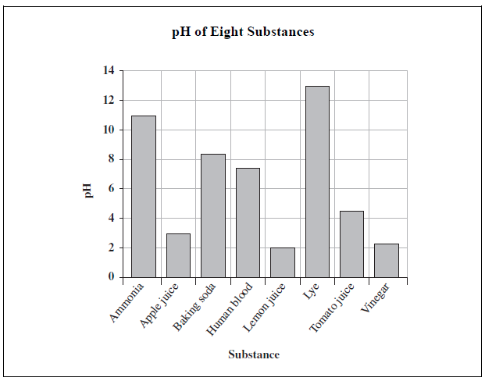

13. Which of the following conclusions can be made from the graph above?

A. Vinegar is more basic than lye.
B. Ammonia is more acidic than apple juice.
C. Tomato juice is more acidic than lemon juice.
D. Baking soda is more basic than human blood.

14. What does biodegradable mean?

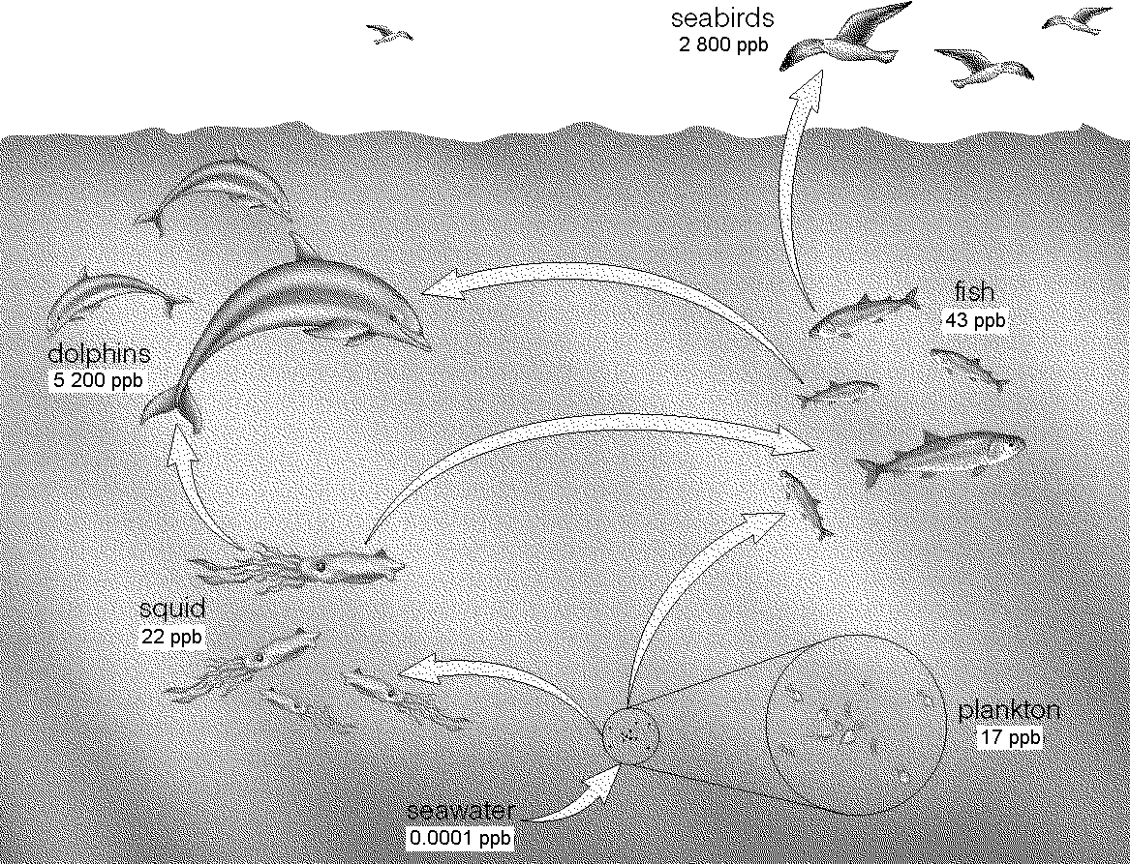
15. To find how much more concentrated
a chemical is. Divide bigger/ smaller.

a) How much more concentrated is the
DDT in dolphins than in squid?

16. The nutritional information label on a cereal box states that each 35 g serving of cereal contains 24 mg of sodium. What is the concentration of sodium in parts per million (ppm)? Careful of units.
Solute = ppm
Solvent 1 000 000

17. A 700 000 mg water sample from the Flow River contains 120ppm of barium. Calculate the amount of barium in the water, in milligrams (mg).

18. If the LD50 of salt is 3000mg/kg in rats, and we feed that amount to 682 rats, how many will be alive at the end of the experiment?

19. Graph reading. What are the phosphate levels, in ppm, when there is an oxygen concentration between 4-6ppm?

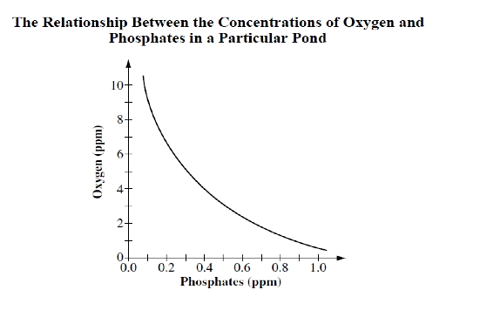

20. Explain what each of these scientific variables means:

a. Manipulated variable

b. Controlled variable

c. Responding variable

