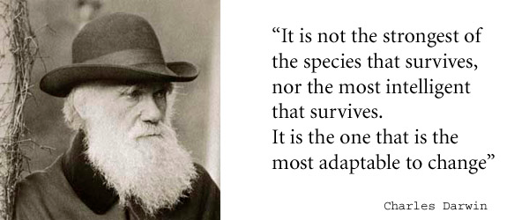
Biodiversity index: Diversity of species in an area divided by the number of species in a given area. Example, there are 3 different species, and 50 animals total in a given area. The diversity index is 6% which is a low biodiversity index.

1) Why did the finches of the Galapagos Islands start eating different food sources?

There was too much competition. They had to adapt of die.

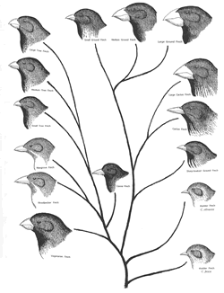
2) Because finches had to start eating different food,
they slowly evolved into different species. Explain
how that happened, and name the process that allowed
this to occur.
Those with variations that allowed them to adapt to other food
Sources got to pass on their genes this is natural selection.

3) Adaptations help an organism better survive their environment, and to better compete with other organisms by allowing organisms to play a specific role in their environment.

This specific role is called a niche

4) Boxers, Basenji and Dingo are all species of dogs, and evolved from a common ancestors thousands of years ago. Explain why they may have changed over the years into three different species. What is this process called?

Speciation- the creation of a new species from a common ancestor.

5) What is the difference between a structural and behavioral adaptation, and give TWO examples of each
BEHAVIORAL | STRUCTURAL (aka physical)
Def: way an animal acts that helps it better survive | Def: something on the animal’s body that helps it better survive and adapt to its niche
Ex 1) puffer fish blows up his chest to appear bigger | Ex 1) large claws on bears for ripping food
Ex 2) owls hinting at night. Less competition then. | Ex 2) large eyes that swivel in chameleons to help them see in all directions.

6) State TWO things we need to classify animals as the same species. Provides examples, and give a non-example.
1) look similar. 2) Be able to reproduce and their offspring can reproduce
Examples of species are horses and donkeys. BUT when a horse and a donkey mate to create a mule, the mule is sterile and not considered a species.

7) An organism that can survive in a range of habitats is called a generalist (aka broad niche)
Give an advantage and a disadvantage of being this:
Adv: can adapt to many food sources or habitats.
Dis: not very good at any one thing, so may be out competed and need to adapt or move elsewhere.

8) An organism that can survive only a narrow range of habitats is called a specialist (aka narrow niche)
Give an advantage and a disadvantage of being this:

Adv: they have adapted to be the best at what they do.
Dis: if food or temperatures change, they do not adapt well and would likely die.

9) A relationship in which two organisms live in direct contact is called a symbiotic relationship

There are three types. Define and give an example of each.

Type: | Mutualism | Commensalism | Parasitism
Definition | Both partners benefit | One benefits and the other is neither helped nor harmed | One benefits and the other is harmed
Example | Clown fish (gets living space)  Anemone (gets protection) | Shark (unaffected)  Remora (gets a free ride to food from shark) | Human (harmed- blood being sucked)  Tape worm (feeding on nutrients from host)

10) Describe the following processes

Budding: Where the offspring grows off the parent and detaches when formed.

Binary Fission the DNA copies and splits into two organisms

Bacterial Conjugation NOT REPRODUCTION. But is the swapping of DNA in bacteria to help mix up genetic material and create diversity. Bacteria can then undergo binary fission to reproduce.

Vegetative reproduction asexual reproduction in plants

Internal fertilization where sperm and egg meet inside the body.

External fertilization sperm and egg meet outside the body.

Asexual spores zoospores. Spore that is a clone of the parent.

Spores zygospores. A mixture of genetic materials.

11) What are the advantages of sexual reproduction over asexual reproduction? What are the disadvantages.
Sexual advantages: creates genetic diversity which helps with adaptations.
Sexual disadvantages: needs to spend lots of time and effort on finding a mate and formation of baby.

Asexual advantages: no need to find a mate or spend a lot of energy on offspring creation. Can rapidly create hundreds of clones
Asexual disadvantage: offspring are all clones of the parent, so there is no genetic diversity and they are susceptible to disease or antibiotics.

12) why is it beneficial for plants to have the option to reproduce sexually and asexually?

Many plants can reproduce both sexually and asexually because their environments are rapidly changing and when conditions are hard or another plant is too far away to swap pollen then it will undergo asexual reproduction. When other plants are close and environmental conditions are favourable (ie. Enough nutrients and water) then it will reproduce sexually.

13) why do areas closer to the equator have a higher diversity index than areas farther away from the equator? In which area would you find more generalists?

Areas closer to the equator have a higher diversity index because the climates are warmer with little change to overall temperature throughout the year. This leads to more organisms adapting to specific niches (ie single trees) and not moving throughout their entire lives because there is no need to adapt to anything else because it doesn’t change.
You would find generalists more frequently the further away from the equator you area because they need to be able to adapt to the drastically changing climate and food sources throughout the year as it gets very cold and hot.

14) explain how we know that the liger cannot be classified as a species yet all breeds or dogs are the same species?

Dogs are all a part of the same species because they can reproduce and create fertile offspring. Ligers are not fertile offspring, and are in fact sterile creatures.

