Math 9
Unit 8: Circle Geometry

Name _______________________
Class_______

Outcomes:

1. Solve problems and justify the solution, using the following circle properties:
• the perpendicular from the centre of a circle to a chord bisects the chord
• the measure of the central angle is equal to twice the measure of the inscribed angle subtended by the same arc
• the inscribed angles subtended by the same arc are congruent
• a tangent to a circle is perpendicular to the radius at the point of tangency.

IXL’s for this unit- It is recommended you do a few questions a night from one of the following IXL’s to keep your knowledge current!
F.1Parts of a circle
F.2Circles: calculate area, circumference, radius and diameter
F.3Circles: word problems
F.4Central angles
F.5Arc measure and arc length
F.6Area of sectors
F.7Circle measurements: mixed review
F.8Arcs and chords
F.9Tangent lines
F.10Perimeter of polygons with an inscribed circle
F.11Inscribed angles
F.12Angles in inscribed right triangles
F.13Angles in inscribed quadrilaterals

9.0- Into: review and terms
Types of angles
1. Acute angles…

2. Right angles...

3. Obtuse angles...

4. Reflex angles...

Properties of Angles
1. Straight Angle –

2. Any angles (two or more) that add up to 180 degrees are also called

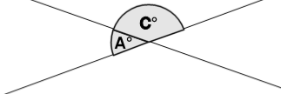
If angle A is 50 degrees, angle C must be ____ degrees.

If angle A were 35 degrees, angle C must be _____ degrees.

Multiple Angles forming a straight angle
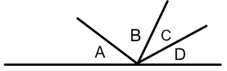

Angles A + B + C + D = _________ degrees.

How can we solve for unknown angles with variables?
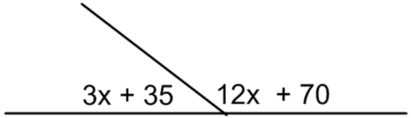

3. Any angles (two or more) that add up to 90 degrees are also
called

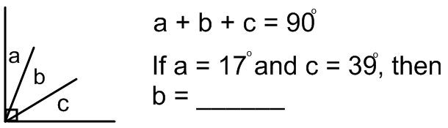

4. Opposite angles…

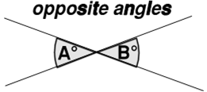

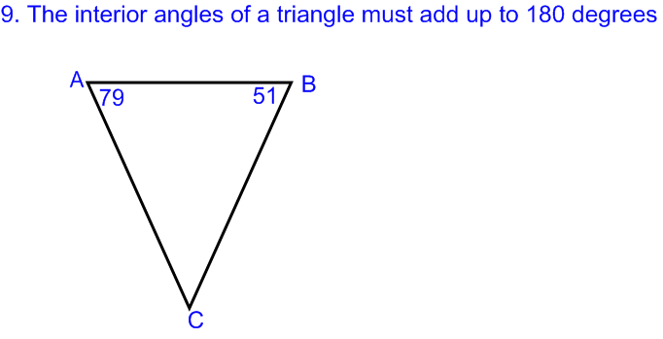
5.

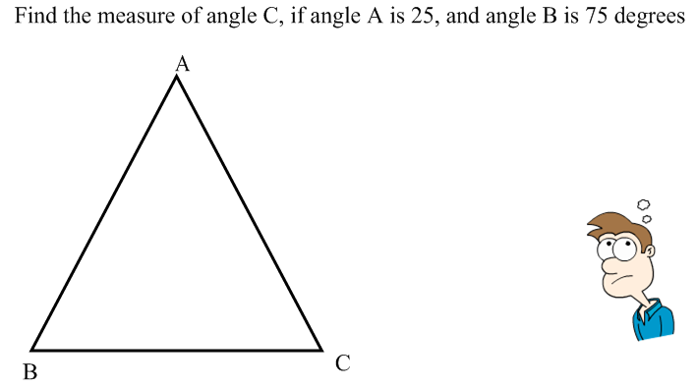

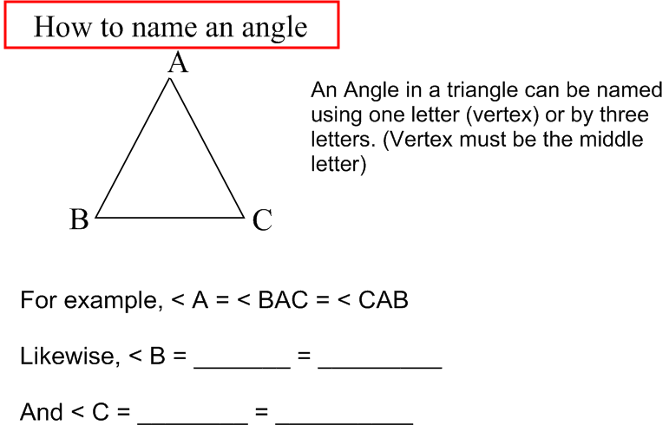

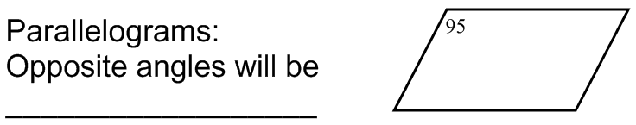

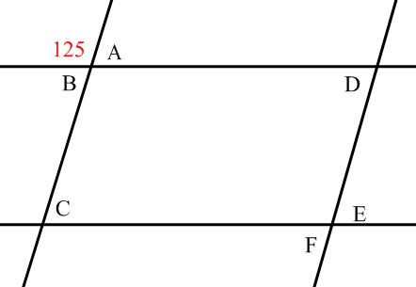

Worksheet: Circle Geometry Intro: Working with angles

9.0b Properties of Circles & Their Definitions

A radius

Chord

Diameter:

Secant:

Tangent

Central Angle

Inscribed Angle

Arc

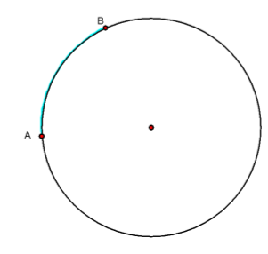
Subtended

Label each Circle Property
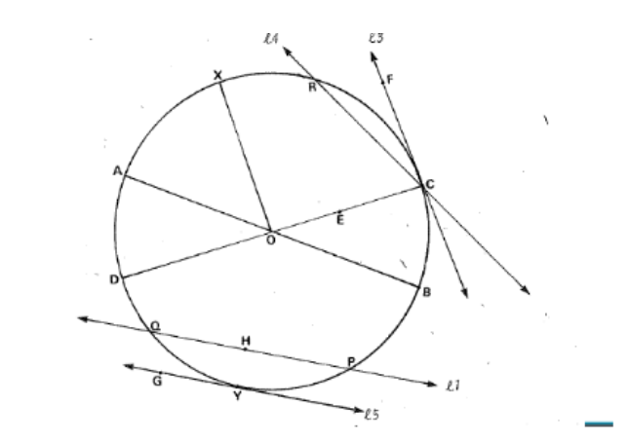
Radius - _______________ Diameter - _______________
Tangent - _______________ Point of Tangency - _______________ Inscribed Angle - _______________ Central Angle - _______________ Chord - _______________ Secant - _______________
Major Arc - _______________ Minor Arc - _______________
IXL F.1 and F.2
9.1 Tangent Property #1:

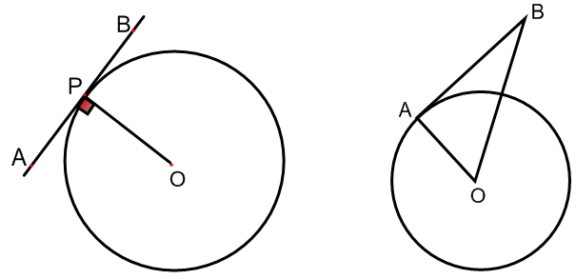
** We use this property to create right triangles. Then we can use Pythagorean theorem to solve for side lengths.

1) What is the measure of BO if the diameter of the circle is 10cm and AB is 6cm?

Tangent Property #2:

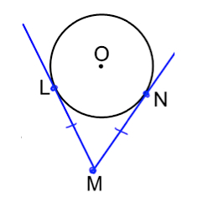
1) If the radius is 5cm and the distance from the origin (centre) to point M is 20cm, can we determine the length of each tangent line to point M?

2. PQ and QS are tangent to N. What is the value of x?
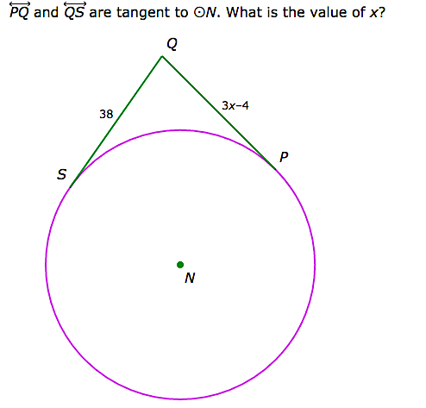

Combining Tangent Properties 1 & 2:
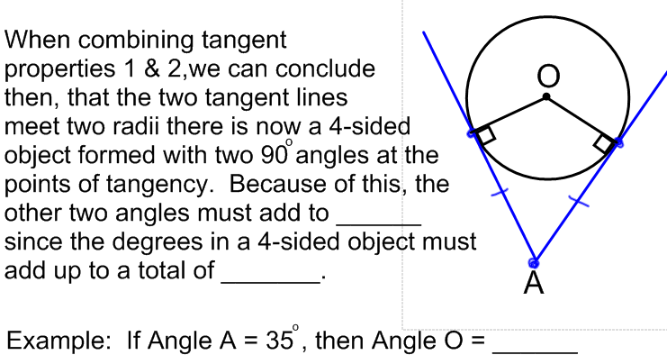

Tangent Property #3: Locating the Origin using Tangent Lines

Tangent Property #4: Parallel Tangent Lines

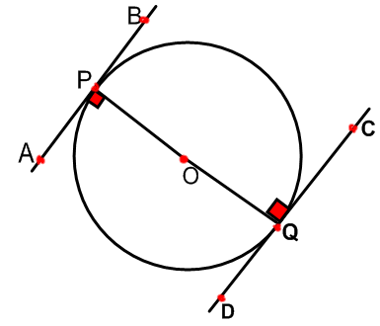

Pythagorean Theorem worksheet
IXL F.9 Tangent Lines

9.2 Chord Properties

Chord properties:

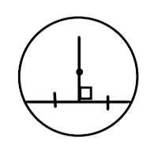

We use these properties to create triangles.

We can combine these 3 chord properties into one rule:

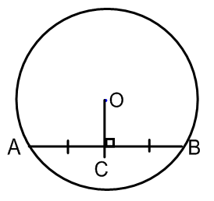

Example #1: Determine the measures of Angles x, y, and z.
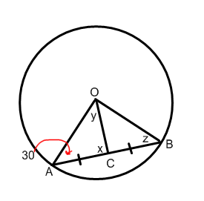

Example #2: O is the center of the circle. Find the length of chord AB.
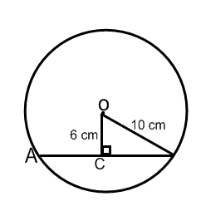

Example #3: AB is a diameter with length 26 cm. CD is a chord that is 10 cm from the center O. What is the length of the chord?
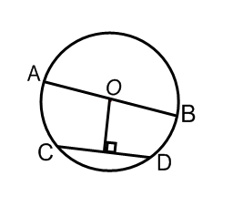

Example #4: A horizontal pipe has a circular cross section, with center O. Its radius is 22 cm. Water fills less than one-half of the pipe. The surface of the water AB is 40 cm wide. Determine the maximum depth of the water (CD).

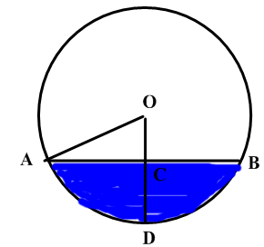

Example #5:

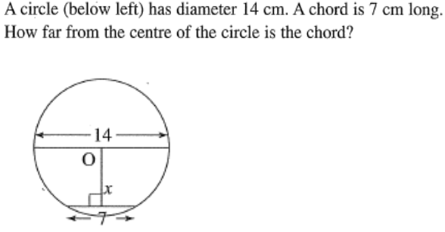
Your turn, try these…
1.

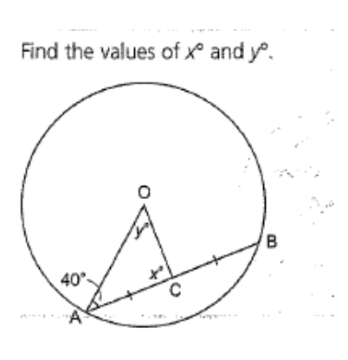
2.

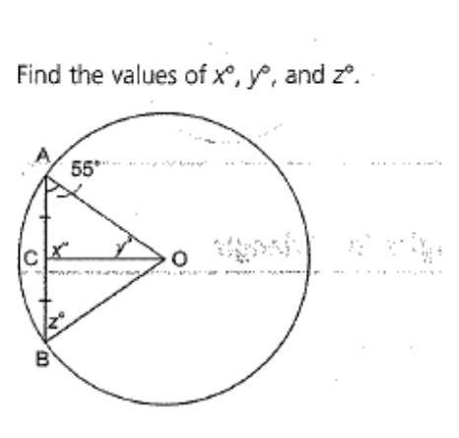
3.

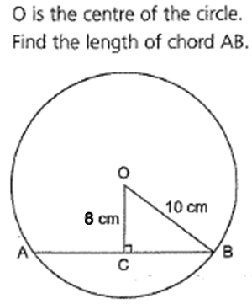
4.

5. AB is a diameter with length 36 cm. CD is a chord that is 10 cm
from the center O. What is the length of the chord?
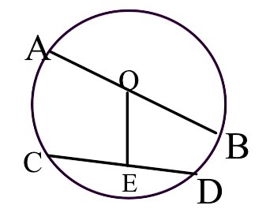

6. A horizontal pipe has a circular cross section with center O.
It has a radius of 20 cm. Water fills less than one-half of the
pipe. The surface of the water AB is 24 cm wide. Determine
the maximum depth of the water which is the depth CD.
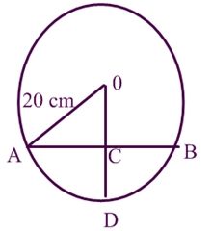

Chord properties worksheet

9.3 Angles and arcs in a Circle

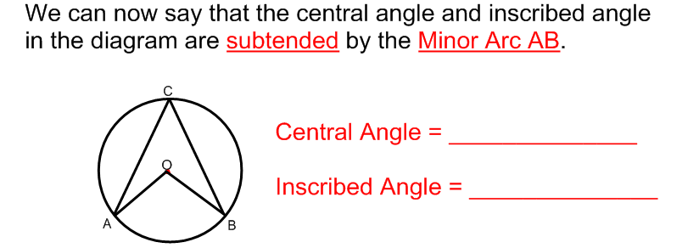

Property #1: Central Angle and Inscribed Angle Property
An inscribed angle and a central angle subtending the same arc follow this rule:
Inscribed angle:

Central angle:

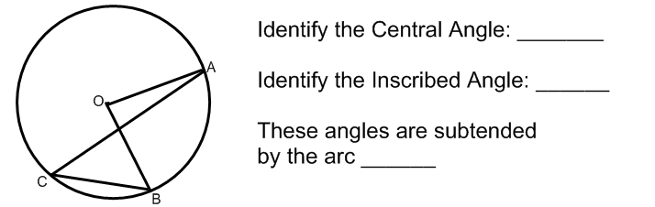
*** <OAC is NOT an inscribed because the sides do not touch the edge of the circle.

Property #2: Inscribed Angle Property
Inscribed angles from the same arc look like a bow-tie in many situations.
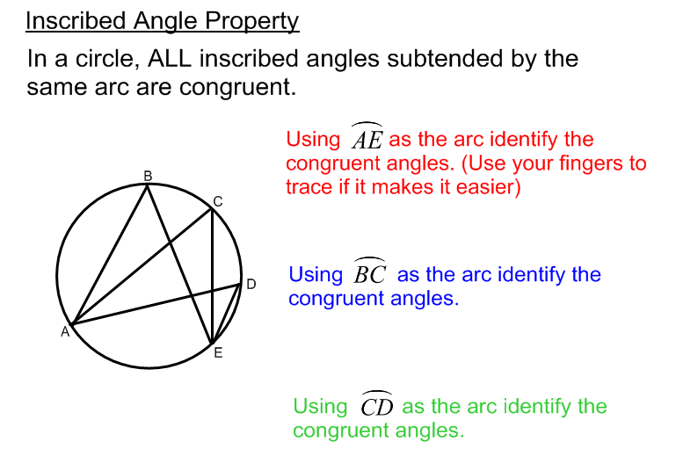

Bow-tie rule:
Angle B= Angle CED=

Angle D = Angle AEC=

Angle E=

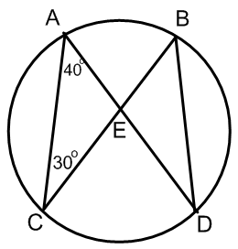

Something to think about….
Can an inscribed angle be formed from a diameter?
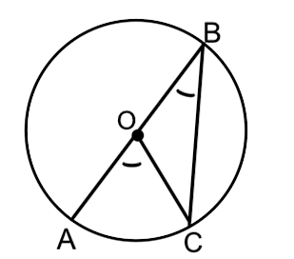

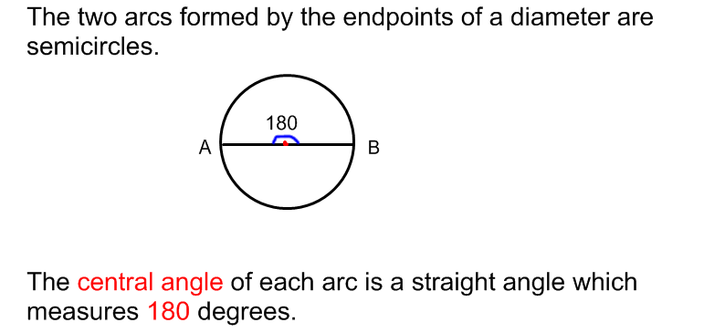

Property #3: Angles in a Semicircle Property

All inscribed angles subtended by a semicircle are _________ angles.
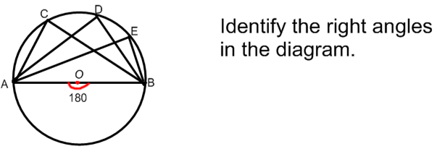

Property #4: Two Tangents to Central Angle Property
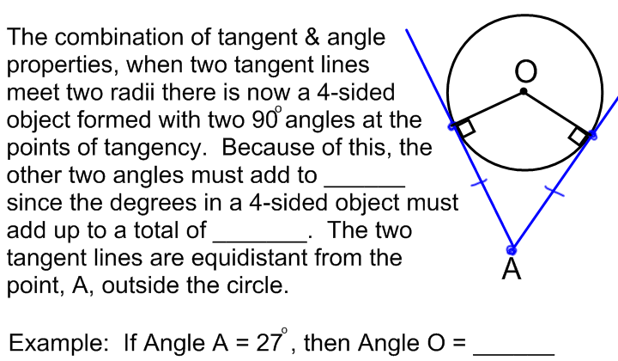

Property #5: Tangent to Chord Property

The angle between the tangent line & the chord is _____________ to the _____________________ angle(s) formed from the same ________ as the chord.
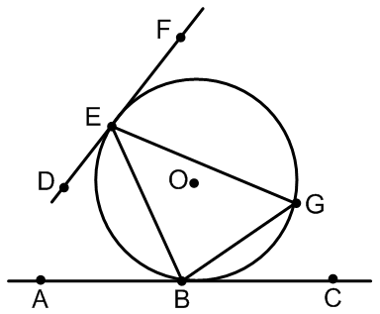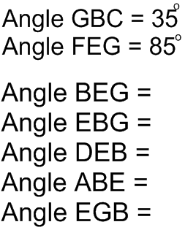

Property #6: Cyclic Quadrilateral Property

A cyclic quadrilateral is a _____-sided polygon (object) inside a circle created by ____ ____________. Since ___-sided polygons have a total of ________, opposite angles of cyclic quadrilaterals MUST add to _______.
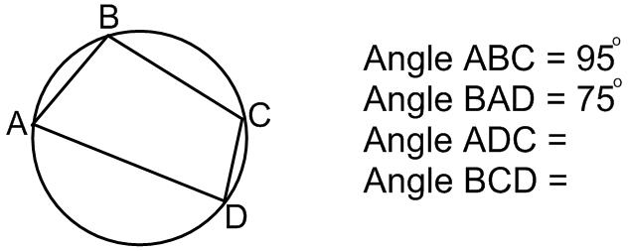
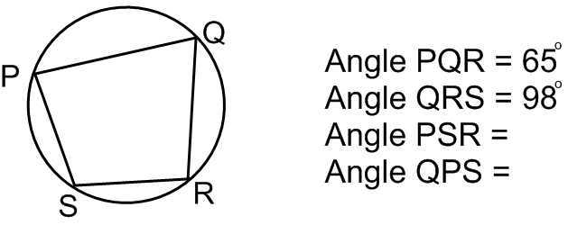

Applying all the properties – Let’s try these together…

Example 1:
Rectangle ABCD has its vertices on a circle with radius 8.5 cm.
The width of the rectangle is 10 cm. What is its length to the nearest tenth?
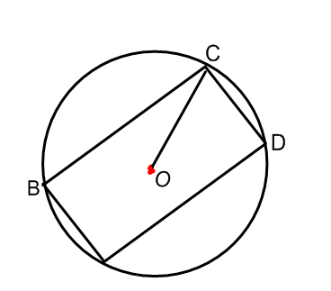
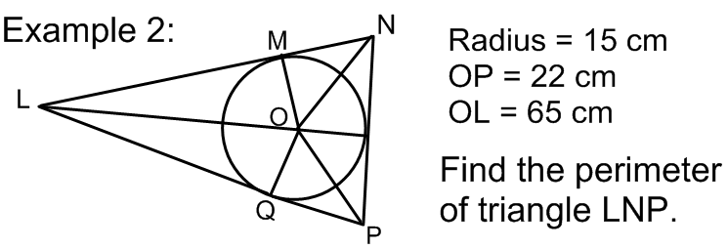

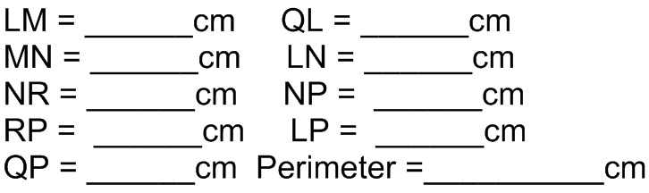

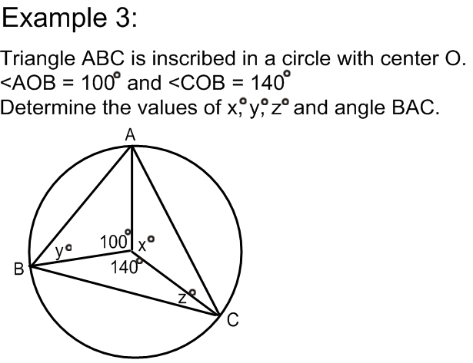

Example 4: Solve all the unknown angles.
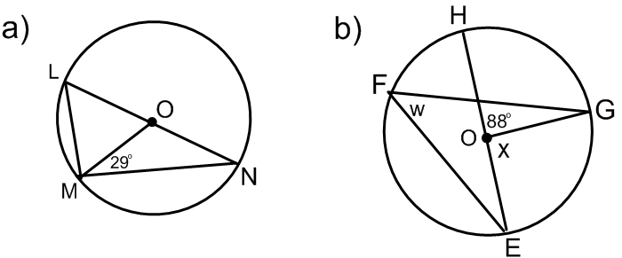

*Bow-tie rule AND inscribed angles subtended by diameter=90º

Arc and angles properties worksheet

