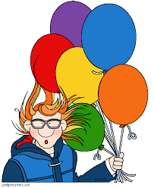
Name ______________________

1) What are the 3 laws of charges. Draw photos to represent them.

2) Explain how a positively charged object becomes neutral. Compare that to how a negatively charged object becomes neutral. (remember, protons cannot move. They are stuck in the nucleus).

3. What is the difference between a conductor, insulator, and semi conductor? Give examples of each.

4. Draw an OPEN and CLOSED circuit. Show the difference.

5. What is the definition of current and voltage (aka potential difference).

6. What do I use to measure current? _______________________________. Where would it go in the circuit below?

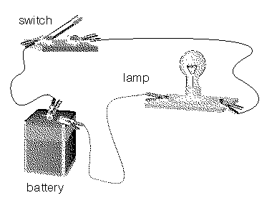
7. What do I use to measure voltage? ________________________________. Where would it go in the circuit below?

8. Draw a series and then a parallel circuit containing a battery with 3V, two bulbs, a switch to control both lights.

9. What does a resistor do? It is measured in: __________________________

10. Fill in the triangle with the Ohm’s equation. Then solve the following problems.

11. A toaster with a resistance of 145 Ω is connected to a 120V source. What current will flow through the toaster?

12. What is the potential difference across a 1500 Ω resistor carrying a current of 0.075A?

13. What is the resistance of an electric heater, if a current of 6A runs through it when it is connected to a 110V wall outlet?

14. What is the resistance of a light bulb if a 35V battery sends a current of 2.4 A through it?

15. A stove with a resistance of 168 Ω is connected to a 120V source. What current will flow through the toaster?

16. What is the potential difference across a 1390 Ω resistor carrying a current of 0.039A (75mA)?

Draw the following circuit drawings:

13) Two lamps and a switch are hooked up in a series with a 3V battery. Show the flow of electricity.

14) Four lamps in parallel with one switch that controls two of the lights but will not affect the other two. Include a 6V battery to power your circuit

